Farmor’s School

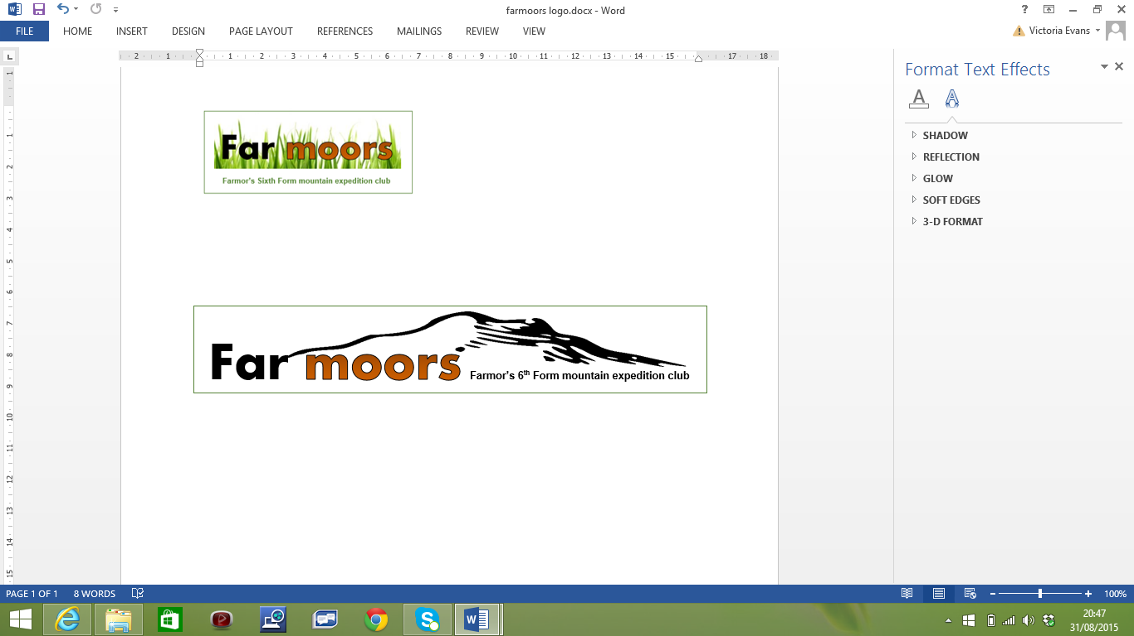

English Three Peaks Challenge
Student information booklet

The English Three Peaks challenge has 3 components:
- Having the fitness to walk 30km (19miles) with 2500m ascent
- Having the endurance to climb 3 mountains: Scafell Pike, Skiddaw, Helvellyn
- Working together as a team to support each other to complete the challenge
- Malverns ridge walk:
When: Sunday 28th January
What time: Be at school for 7am, we should return before 6pm
What to bring: See the kit list, appendix 1
Food required: Packed lunch in addition to snacks
Briefing/kit check Weds 17th Jan break time LRC
This is designed to test the first and third components. At just over 10 miles long (one way) the Malvern ridge provides the ideal first challenge. This will be the first opportunity for the leaders (and perhaps yourself) to assess your fitness and equipment. We will begin to design the walking groups you’ll be in for the next challenges.

- Yorkshire 3 Peaks Challenge:
When: Friday 23rd March - Sunday 25th March
What time: Leave school at 4.00pm, we should return on Sunday around 1pm
What to bring: See the kit list, appendix 1 (sleeping bag & pillow needed)
Food required: Packed lunch for Saturday, cash for Sat dinner and Sun lunch
Briefing/kit check Weds 14th March break time LRC
Preparation for the challenge must include some exposure to steep and rocky terrain. Whilst the Malvern’s ridge walk is a good test of endurance, it does not expose participants to significant heights. Leaders will use this weekend to re-assess strength, stamina and kit, as well as the ability to climb uphill, at pace, for extended periods of time. This weekend is designed to test all 3 components, can you walk 25 miles, climb 3 mountains and still play your part in the team?

- Snowdonia Weekend
When: Friday 27th April - Sunday 29th April
What time: Leave school at 4.00pm, we should return on Sunday before 5pm
What to bring: See the kit list, appendix 1 (sleeping bags & pillow needed)
Food required: Packed lunch for Saturday, cash for Fri & Sat dinner and Sun lunch
Briefing/kit check Wednesday 18th April break time LRC
Preparation for the challenge must include exposure to steep and rocky terrain for a sustained period. We will aim to climb Snowdon in a reasonably fast time to check fitness and foot placement. We aim to do a night walk in order to introduce students to using head torches and walking whilst disorientated. Leaders will use this weekend to assess strength, stamina, teamwork, kit and the ability to climb in mountainous terrain, for extended periods of time.

- English 3 Peaks Challenge: The main event
When: Thursday 12th July - Sunday 15th July
What time: Be ready to leave school at 1.30pm, we should return to school on Sunday around 5pm (RIAT weekend – so traffic dependent)
What to bring: See the kit list, appendix 1 (sleeping bags may be needed- tbc)
Food required: Packed lunch for Friday, cash for Thurs, Fri & Sat dinner and Sun lunch
Briefing/kit check Wednesday 4th July break time LRC

For the team to complete the challenge it is essential that all participants are well prepared for the weekends. Here are 2 reasons why some attempts have not been completed in the target time (or at all):

- Fitness:
The leaders use the organised training weekends to assess fitness, it’s up to you to maintain that up to the challenge weekend. It’s no fun being at the back of the group all weekend!
More details in appendix 4

- Equipment:
Hypothermia is a real risk on the mountains, even in the middle of summer (it’s called Snowdon for a reason). If you have not got warm clothing, good waterproofs or worn in walking boots you put yourself and the group at risk (so we won’t let you walk).
Not eating or drinking enough increases the risk, ensure you have plenty for the weekend and eat regularly.
More details in appendix 1 and 2

Any venture into the upland environment comes with risk and responsibility:
Risk: The terrain can be tough to negotiate and the weather can change at any point; this presents potentially challenging conditions for any group out on the mountains. Students will be expected to follow the instructions of the qualified and experienced Mountain Leaders at all times.
Responsibility: As visitors to unspoilt National Park areas we have a responsibility to leave the mountains as we found them. Inevitably our presence will have an impact and we will try to keep that to an absolute minimum (use of facilities, traffic and noise pollution etc). To put something back into the area it is a condition of participation that students should spend some time volunteering with a Welsh conservation charity (details to be confirmed). We hope this will help you to appreciate the work that is involved in mitigating the environmental impact of our event.

Appendix

Equipment - Suggested kit list:
Personal walking kit - bold items should be brought to kit check meetings for inspection
Note, food will be not issued and should be carried on an individual basis.
- Rucksack (35-40 litres recommended)
- Waterproof rucksack liner
- Waterproof jacket
- Waterproof trousers
- Head torch + spare batteries
- Walking socks + spare pair
- Walking boots (broken in)
- Gaiters
- Drink (water bottle of at least 2L Capacity – or 2x 1L bottles).
Don’t use a camel/bladder pack unless it’s been sterilised before each weekend
- Whistle (The emergency signal is 3 short blasts in quick succession, repeated at 1-minute intervals)
- Hat + Gloves
- 2 x spare warm layer (e.g. fleece)
- Spare food / snacks
- Personal first aid and sanitary supplies (including asthma inhaler if required)
- Sunglasses, sun cream and sun hat
- Mobile phone
- Antiseptic gel / wet wipes

- Optional map & compass / GPS
- Optional Walking Poles

Group kit, you may be asked to carry some of this for the leaders, but don’t need to provide it yourselves:
- Group first aid kit - Penknife
- Additional fleece - Additional spare hat, gloves
- Basic repair kit (cable ties, tape etc) - Hand warmers
- Spare map and compass - Flask with a hot drink
- Emergency phone in waterproof case - Group shelters

Suggestions for personal kit for the weekends:
- Comfortable travel clothes - Travel pillow / sleep eye mask
- Toiletries - Towel
- Vaseline - Deodorant
- Pain killers (e.g. ibruprofen) - Baby wipes
- Small flask or thermal mug - Zinc oxide tape
- Deep Heat / Wintergreen / muscle rub - Hand wash (the type which evaporates)
- Sleeping bag - Packed lunche(s) & snacks

Spare clothes:
- Trousers (not cotton or jeans)
- Base layers
- Fleece
- Socks
- Underwear
- Indoor shoes

Nutrition
2.1 It is very important to prepare properly for this event in terms of your diet, particularly given our objective of completing the three peaks within such a tight time frame. Therefore all food that you will need to consume should be packed with you and taken on board the minibus. This will require preparation.
Either two days before, or at least the night before the big weekend, you should be eating plenty of carbohydrates in the evenings. This is the good bit...eating lots! Example meals might be: rice dishes, potato, or pasta with some meat or another source of protein (e.g. beans, nuts, fish). N.B. Don't eat excessive amounts, but do fill yourself up.
2.2 In terms of between walks...
Obviously consume plenty of water - possibly as much as 2 litres during, before and after each of the 3 legs. This will clearly depend on the weather conditions though. Water supplies can be refilled on completion of each peak.
Snacks for between and during walks could include: mars bars, boiled sweets, jelly babies, flapjacks, cereal bars, fruit (especially bananas), Jaffa cakes. Such foods are all very good in terms of providing you with a quick energy boost. Fruit juice is also very good for this. In terms of sports drinks, you don’t need them, water is the best way of staying hydrated.
Packed lunch style food to replace carbohydrate stores could include: sandwiches, cold pasta, wraps, cold rice, etc. This should be eaten after each of the three walks - so it would be wise to pack one lunch portion per peak.
2.3 Roughly 10 mins before each walk it's good to have one of your sugary/fruity snacks - this will help you maintain your energy levels for the last stint of each of peak.

2.4 Even if you feel too tired to eat after a peak, it is very important that you do so before you rest to keep both your energy levels up and in order to keep your concentration on the next peak.

2.5 Since we'll obviously be keen to stay on the move, it is important that we all come thoroughly prepared with our food requirements. It is also a good idea to bring along food and drink that your body is used to.

Example nutrition plan – use this to help you with your shopping list.
Wednesday night:
Dinner: large portion of a carbohydrate based meal (e.g. pasta, rice, or potato based dinner).
Thursday
Breakfast: eat a large portion of cereal (porridge is great) and toast with Jam or similar.
Lunch: eat pasta or two rounds of sandwiches, nuts, fruit, before we set off
Dinner: bring money to eat at the services station on the way up to the Lakes – pasta, rice, potatoes based
Friday
Breakfast: provided
Lunch: bring pasta or two or three rounds of sandwiches, nuts, fruit, and chocolate bar.
Dinner: bring money to eat at the pub
Saturday & Sunday:
We will provide breakfast for both days and a packed lunch for Saturday. You will need cash for Saturday night and Sunday lunch.

3. FINANCES

  - £300 - This covers insurance, transport, accommodation, group equipment, breakfasts and Saturday lunch (other meals are not included)
- £50 to be paid by 15th Dec 2017
- £250 remaining balance by 19th January

Individuals need to budget for:
- Individual kit
- Snacks and packed lunches
- Dinner on Friday & Saturday nights and Sunday lunch
- Anything outside the standard plan

  - Sponsorship of £100 minimum to go to a charity of the group’s choice

4. Training
It is the individual’s own responsibility to ensure that they are fit enough to complete the challenge and are sufficiently skilled and prepared in case of an emergency.

4.1 Organised Training for the English 3 Peaks Challenge:
These events will give participants:
- The chance to assess mountain fitness
- Mountain walking experience on steep uneven terrain
- Specific training for leg muscles
- An opportunity to test out kit
- A chance to further bed in boots
And give the organisers a view as to how groups should be arranged for the actual event.
Before an attempt on the English 3 peaks in July all participants should have completed as a minimum:
- A 20 mile walk in the Malverns in January
- A successful attempt on the Yorkshire 3 Peaks
- A successful attempt on Snowdon

Those that have not completed all training walks will be assessed individually. Decisions on suitability will be ongoing during the weekends. The decision of a student’s suitability to complete the challenge is made by Mr Eckersley and is final.

4.2 Individual Training Schedule
- Students are assessed on the training walks and given advice on training programs, especially where skills are lacking eg sure-footedness, climb stamina.
- These skills should be practiced by the participants where possible over the next 6 months
- Other sporting commitments are encouraged, any regular sporting activity to maintain fitness is vital to a successful English 3 Peaks Challenge.

eXPEDITION Rules

5.1 Team Rules

Safety
- Safety is paramount – going on this trip is optional – coming back is mandatory!
- Insurance has been arranged
- The Risk Assessment has been completed by Mr Eckersley and his nominated Team Leaders
- No alcohol on the trip
- You will be tired, physically and mentally, not least from the physical effort and lack of sleep. Recognise this and moderate your behaviour and decision making accordingly.

5.2 Mountain Rules
- Whilst on the mountain, the Group Leader’s decision is final.
- Individual and Team safety is paramount.
- Walkers are to remain with their group and move as a unit on the mountain, unless in an emergency situation (covered separately).
- If necessary the Group Leader (in conjunction with team leaders) will decide on new group formations and/or leaders.
- Groups will set off within 5 min at the start of each climb.
- Keep noise to a minimum near inhabited areas (mountain bases).
- Be prepared to give way to other walkers going in same or opposite direction.
- Take care when passing other walkers.
- Keep to single file in narrow sections.
- Do not move off the path / trail as this could damage the path edge.
- If you are using a head torch, take care not to ‘blind’ your fellow walkers or degrade the amount of the natural light available.
- Do not leave litter on the mountain – take it with you back to the bus. Each bus will have a supply of bin bags.
- If you do need the toilet whilst on the mountain, please be discreet and try not to leave anything behind (!).
- If you need a wee, please try to avoid caves or summit shelters – out in the open is best.
- If you need something other than a wee, remember that toilet paper or wet wipes take a long time to breakdown, so please bring a self-seal bag to carry used items out. Burying should be seen as a last resort!
- The same applies to female sanitary items i.e. please bring a self-seal bag.
- And just as it was drilled in to you when you were (much) younger, it is essential to clean hands after toileting, so please bring wet wipes / antiseptic gel and as before, a self-seal bag.
- If a group member becomes injured or unwell, or you meet someone who needs help, offer them help immediately.

